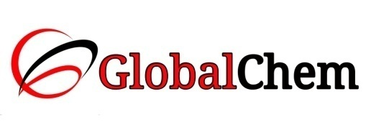

**CERTIFICATE OF ANALYSIS**

Product Name: AMMONIUM FERROUS SULPHATE HEXAHYDRATE EXTRA PURE

Code no. : AHS1000 CAS no. : 7783-85-9

Lot no. : L160911507 Mfg date: JUL-2015

Exp date: JUN-2020 Analyzed on: 14/07/15

|  |  |  |  |
| --- | --- | --- | --- |
| Sr. no. | Tests | Specifications | Results |
| 1 | Description | Greenish blue crystals / crystalline powder | Greenish blue crystals |
| 2 | Assay (Oxidimetric) | Min. 98.5% | 99.03% |
| 3 | Chloride (Cl) | Max. 0.005% | 0.0024% |
| 4 | Ferric Ion (Fe) | Max. 0.05% | 0.02% |

This document has been produced electronically and it is valid without signature.