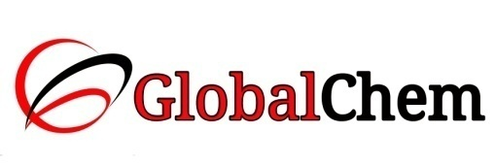

**CERTIFICATE OF ANALYSIS**

Product Name: NITRIC ACID AR/ACS

Code no. : ANI1000 CAS no. : 7697-37-2

Lot no. : B177601510 Mfg date: OCT-2015

Exp date: SEPT-2020 Analyzed on: 04/10/15

|  |  |  |  |
| --- | --- | --- | --- |
| Sr. no. | Tests | Specifications | Results |
| 1 | Description | A clear colourless liquid | Clear colourless liquid |
| 2 | Assay | 69 - 70.0% | 69.35% |
| 3 | Colour | Max. 10 APHA | Passes |
| 4 | Wt. per ml at 20°C | 1.41 - 1.42 g | 1.4125 g |
| 5 | Residue on ignition | Max. 0.0005% | 0.0005% |
| 6 | Chloride (Cl) | Max. 0.00005% | 0.000025% |
| 7 | Phosphate and silicate (SiO2) | Max. 0.0001% | 0.00005% |
| 8 | Sulphate (SO4) | Max. 0.0001% | 0.000079% |
| 9 | Arsenic (As) | Max. 0.000001% | <0.000001% |
| 10 | Copper (Cu) | Max. 0.00001% | 0.0000027% |
| 11 | Iron (Fe) | Max. 0.00002% | 0.000020% |
| 12 | Heavy metal (as Pb) | Max. 0.00002% | 0.0000027% |
| 13 | Manganese (Mn) | Max. 0.00004% | 0.00000039% |

This document has been produced electronically and it is valid without signature.