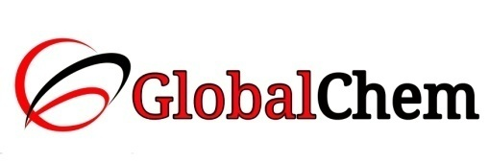

**CERTIFICATE OF ANALYSIS**

Product Name: SODIUM CHLORIDE AR/ACS

Code no. : SCL1000 CAS no. : 7647-14-5

Lot no. : B169321510 Mfg date: OCT-2015

Exp date: SEPT-2020 Analyzed on: 05/10/15

|  |  |  |  |
| --- | --- | --- | --- |
| Sr. no. | Tests | Specifications | Results |
| 1 | Description | White crystalline powder | White crystalline powder |
| 2 | Assay (after ignition) | 99.5 - 100.5% | 99.9% |
| 3 | Identity | Passes test | Passes test |
| 4 | Appearance of solution | Passes test | Passes test |
| 5 | Insoluble matter | Max. 0.005% | 0.00031% |
| 6 | Acidity or Alkalinity | Passes test | Passes test |
| 7 | pH of 5% solution | 5.0 - 8.0 | 5.8% |
| 8 | Bromide | Max. 0.005% | 0.0038% |
| 9 | Iodide | Max. 0.001% | 0.0004% |
| 10 | Ferrocyanide (Fe(CN)6) | Max. 0.0001% | 0.00005% |
| 11 | Chlorate & Nitrate (NO3) | Max. 0.003% | 0.0024% |
| 12 | Nitrite (NO2) | Passes test | Passes test |
| 13 | Phosphate (PO4) | Max. 0.0005% | 0.00024% |
| 14 | Sulphate (SO4) | Max. 0.001% | 0.00033% |
| 15 | Total nitrogen | Max. 0.0005% | 0.0004% |
| 16 | Heavy metals (as Pb) | Max. 0.0005% | 0.00032% |
| 17 | Arsenic (As) | Max. 0.00004% | 0.00002% |
| 18 | Barium (Ba) | Max. 0.001% | 0.00073% |
| 19 | Calcium (Ca) | Max. 0.002% | 0.00022% |
| 20 | Copper (Cu) | Max. 0.0002% | 0.00018% |
| 21 | Iron (Fe) | Max. 0.0002% | 0.000164% |
| 22 | Magnesium (Mg) | Max. 0.001% | 0.00017% |
| 23 | Magnesium & alkali earth metal (as Ca) | Max. 0.01% | 0.0046% |
| 24 | Potassium (K) | Max. 0.005% | 0.00202% |
| 25 | Loss on drying  (105°C for 2hrs) | Max. 0.5% | 0.40% |

This document has been produced electronically and it is valid without signature.