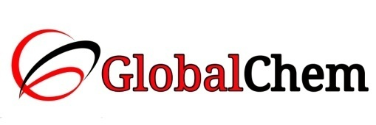

**CERTIFICATE OF ANALYSIS**

Product Name: SODIUM HYDROXIDE PELLETS AR/ACS

Code no. : SHI1000 CAS no. : 1310-73-2

Lot no. : B163891504 Mfg date: APR-2015

Exp date: MAR-2020 Analyzed on: 09/04/15

|  |  |  |  |
| --- | --- | --- | --- |
| Sr. no. | Tests | Specifications | Results |
| 1 | Description | White deliquescent pellets or pearls | White deliquescent pellets |
| 2 | Assay (Acidimetric) | 98.0 – 100.5% | 98.09% |
| 3 | Identity according to pharmacopoeia | Passes test | Passes test |
| 4 | Appearance of solution | Passes test | Passes test |
| 5 | Insoluble matter in water | Max. 0.025% | <0.025% |
| 6 | Sodium Carbonate (as Na2CO3) | Max. 1.0% | 0.70% |
| 7 | Chloride (Cl) | Max. 0.005% | 0.005% |
| 8 | Sulphate (SO4) | Max. 0.003% | 0.00015% |
| 9 | Phosphate (PO4) | Max. 0.001% | <0.001% |
| 10 | Silicate (SiO2) | Max. 0.001% | <0.001% |
| 11 | Total Nitrogen (N) | Max. 0.0003% | <0.0003% |
| 12 | Heavy metals (as Pb) | Max. 0.002% | 0.00017% |
| 13 | Heavy metals (as Ag) | Max. 0.002% | 0.00037% |
| 14 | Iron (Fe) | Max. 0.001% | 0.00087% |
| 15 | Nickel (Ni) | Max. 0.001% | 0.00014% |
| 16 | Aluminium (Al) | Max. 0.0005% | <0.0005% |
| 17 | Calcium (Ca) | Max. 0.005% | 0.000062% |
| 18 | Potassium (K) | Max. 0.02% | <0.02% |
| 19 | Magnesium (Mg) | Max. 0.002% | 0.000049% |
| 20 | Mercury (Hg) | Max. 0.00001% | <0.00001% |

This document has been produced electronically and it is valid without signature.