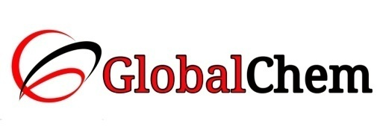

**CERTIFICATE OF ANALYSIS**

Product Name: SODIUM SULPHATE ANHYDROUS AR/ACS

Code no. : SSU1000 CAS no. : 7757-82-6

Lot no. : B177291511 Mfg date: NOV-2015

Exp date: OCT-2020 Analyzed on: 05/11/15

|  |  |  |  |
| --- | --- | --- | --- |
| Sr. no. | Tests | Specifications | Results |
| 1 | Description | A white crystalline powder | A white crystalline powder |
| 2 | Assay (Ion sensitive electrode) | Min. 99.0% | 99.73% |
| 3 | Insoluble matter | Max. 0.01% | 0.0089% |
| 4 | pH (5% water) | 5.2 – 9.2 | 6.93 |
| 5 | Chloride (Cl) | Max. 0.001% | 0.000199% |
| 6 | Phosphate (PO4) | Max. 0.001% | 0.00039% |
| 7 | Total nitrogen (N) | Max. 0.0005% | <0.0005% |
| 8 | Heavy metals (as Pb) | Max. 0.0005% | 0.00043% |
| 9 | Arsenic (As) | Max. 0.0001% | <0.0001% |
| 10 | Calcium (Ca) | Max. 0.01% | 0.000967% |
| 11 | Iron (Fe) | Max. 0.0005% | 0.00044% |
| 12 | Potassium (K) | Max. 0.002% | 0.000315% |
| 13 | Magnesium (Mg) | Max. 0.001% | 0.00057% |
| 14 | Loss on ignition at 800°C | Max. 0.5% | 0.259% |

This document has been produced electronically and it is valid without signature.