SECTION 1: Identification of the substance/mixture and of the company/undertaking

1.1. Product identifier
Product form | : | Substance
 | :
EC index no | : | 603-001-00-X
EC no | : | 200-659-6
CAS No | : | 67-56-1
Product code | : | MET1000
Formula | : | CH4O

1.2. Relevant identified uses of the substance or mixture and uses advised against

1.2.1. Relevant identified uses
No additional information available

1.2.2. Uses advised against
No additional information available

1.3. Details of the supplier of the safety data sheet
GlobalChem / Cosela S.L.
Parsi 1, 7
41016 Sevilla - SPAIN
T +34 678788064 - F +34 954255812
info@globalchem.es - www.globalchem.es

1.4. Emergency telephone number
No additional information available

SECTION 2: Hazards identification

2.1. Classification of the substance or mixture

Classification according to Regulation (EC) No. 1272/2008 [CLP]Mixture/Substance: SDS EU 2015: According to Annex II of Regulation (EC) No. 453/2010 (REACH Annex II)
Flammable liquids, Category 2 | H225
Acute toxicity (dermal), Category 3 | H311
Acute toxicity (inhal.), Category 3 | H331
Acute toxicity (oral), Category 3 | H301
Specific target organ toxicity — single exposure, Category 1 | H370
Full text of classification categories and H statements : see section 16

Adverse physicochemical, human health and environmental effects
No additional information available

2.2. Label elements

Labelling according to Regulation (EC) No. 1272/2008 [CLP] Extra labelling to displayExtra classification(s) to display
Hazard pictograms (CLP) | : | 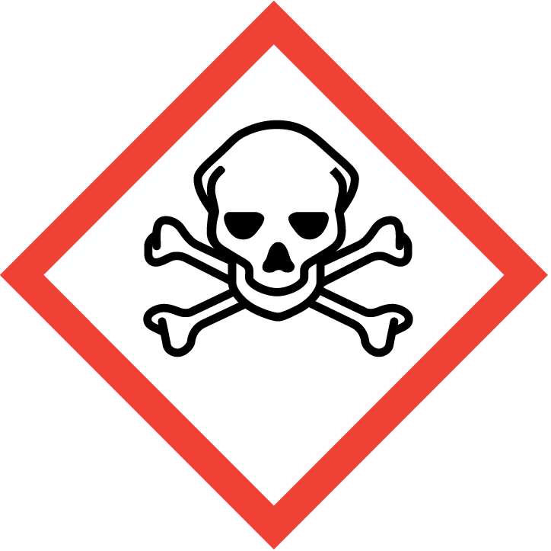  GHS06 | 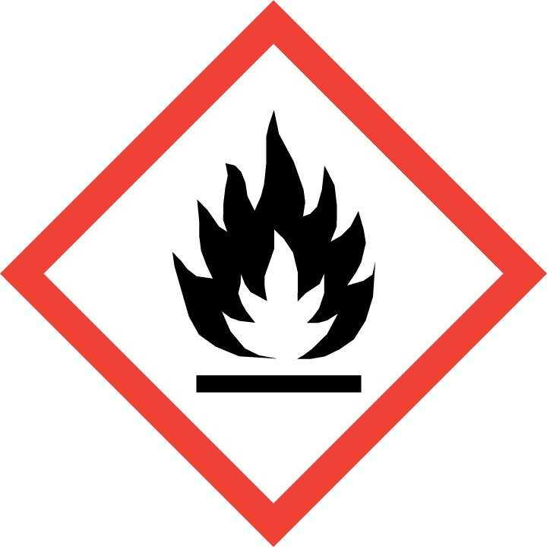  GHS02 | 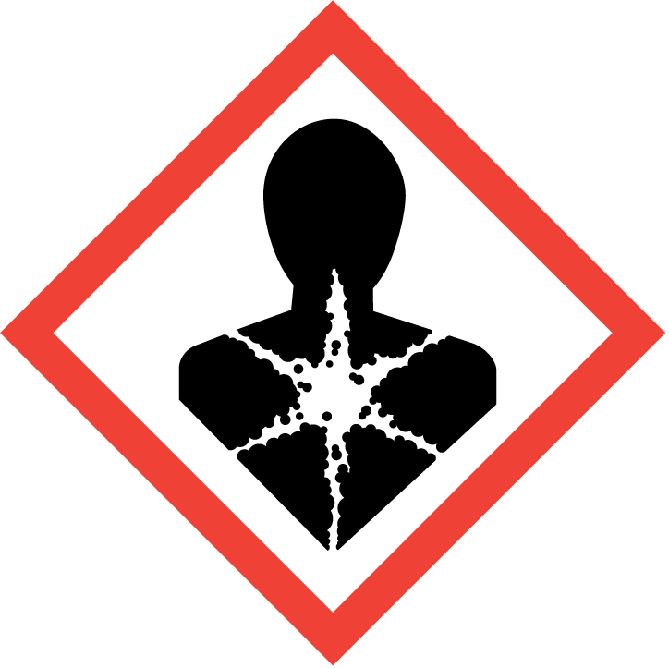  GHS08
Signal word (CLP) | : | Danger
Hazard statements (CLP) | : | H225 - Highly flammable liquid and vapour  H301+H311+H331 - Toxic if swallowed, in contact with skin or if inhaled  H370 - Causes damage to organs
Precautionary statements (CLP) | : | P210 - Keep away from heat, hot surfaces, sparks, open flames and other ignition sources. No smoking  P233 - Keep container tightly closed  P240 - Ground/bond container and receiving equipment  P241 - Use explosion-proof electrical/ventilating/lighting/… equipment  P260 - Do not breathe dust/fume/gas/mist/vapours/spray  P264 - Wash ... thoroughly after handling  P270 - Do not eat, drink or smoke when using this product  P271 - Use only outdoors or in a well-ventilated area  P280 - Wear protective gloves/protective clothing/eye protection/face protection  P301+P310 - IF SWALLOWED: Immediately call a POISON CENTER/doctor/…  P302+P352 - IF ON SKIN: Wash with plenty of water/…  P303+P361+P353 - IF ON SKIN (or hair): Take off immediately all contaminated clothing. Rinse skin with water/shower  P304+P340 - IF INHALED: Remove person to fresh air and keep comfortable for breathing  P308+P311 - IF exposed or concerned: Call a POISON CENTER/doctor/…  P311 - Call a POISON CENTER/doctor/…  P321 - Specific treatment (see ... on this label)  P330 - Rinse mouth  P361+P364 - Take off immediately all contaminated clothing and wash it before reuse  P370+P378 - In case of fire: Use ... to extinguish  P403+P233 - Store in a well-ventilated place. Keep container tightly closed  P403+P235 - Store in a well-ventilated place. Keep cool  P405 - Store locked up  P501 - Dispose of contents/container to ..

2.3. Other hazards
No additional information available

SECTION 3: Composition/information on ingredients

3.1. Substance

Name | Product identifier | %
METHANOL 99.8% AR/ACS | (CAS No) 67-56-1  (EC no) 200-659-6  (EC index no) 603-001-00-X | 100

Full text of H-phrases: see section 16

3.2. Mixture
Not applicable

SECTION 4: First aid measures

4.1. Description of first aid measures
First-aid measures general | : | Call a POISON CENTER or doctor/physician. Specific treatment (see ... on this label).
First-aid measures after inhalation | : | Remove victim to fresh air and keep at rest in a position comfortable for breathing.
First-aid measures after skin contact | : | Rinse skin with water/shower. Remove/Take off immediately all contaminated clothing. Immediately call a POISON CENTER or doctor/physician. Wash with plenty of soap and water. Specific measures (see ... on this label). Wash contaminated clothing before reuse.
First-aid measures after eye contact | : | Remove contact lenses, if present and easy to do. Continue rinsing. Rinse cautiously with water for several minutes.
First-aid measures after ingestion | : | Rinse mouth. Obtain emergency medical attention. Immediately call a POISON CENTER or doctor/physician. Specific treatment (see ... on this label).

4.2. Most important symptoms and effects, both acute and delayed
Symptoms/injuries | : | Causes damage to organs.
Symptoms/injuries after skin contact | : | Repeated exposure to this material can result in absorption through skin causing significant health hazard. Toxic in contact with skin.
Symptoms/injuries after ingestion | : | Toxic if swallowed. Swallowing a small quantity of this material will result in serious health hazard.

4.3. Indication of any immediate medical attention and special treatment needed
No additional information available

SECTION 5: Firefighting measures

5.1. Extinguishing media
No additional information available

5.2. Special hazards arising from the substance or mixture
Fire hazard | : | Highly flammable liquid and vapour.
Explosion hazard | : | May form flammable/explosive vapour-air mixture.

5.3. Advice for firefighters
No additional information available

SECTION 6: Accidental release measures

6.1. Personal precautions, protective equipment and emergency procedures
General measures | : | Remove ignition sources. Use special care to avoid static electric charges. No naked lights. No smoking.

6.1.1. For non-emergency personnel
No additional information available
6.1.2. For emergency responders
Protective equipment | : | Avoid breathing dust/fume/gas/mist/vapours/spray.

6.2. Environmental precautions
No additional information available

6.3. Methods and material for containment and cleaning up
No additional information available

6.4. Reference to other sections
No additional information available

SECTION 7: Handling and storage

7.1. Precautions for safe handling
Additional hazards when processed | : | Handle empty containers with care because residual vapours are flammable.
Precautions for safe handling | : | No naked lights. No smoking. Use only non-sparking tools. Do not breathe dust/fume/gas/mist/vapours/spray.
Hygiene measures | : | Do not eat, drink or smoke when using this product. Wash ... thoroughly after handling.

7.2. Conditions for safe storage, including any incompatibilities
Technical measures | : | Proper grounding procedures to avoid static electricity should be followed. Ground/bond container and receiving equipment. Use explosion-proof electrical/ventilating/lighting/… equipment.
Storage conditions | : | Keep in fireproof place. Keep container tightly closed.
Incompatible materials | : | Heat sources.

7.3. Specific end use(s)
No additional information available

SECTION 8: Exposure controls/personal protection

8.1. Control parameters
No additional information available

8.2. Exposure controls
Respiratory protection | : | Where exposure through inhalation may occur from use, respiratory protection equipment is recommended

SECTION 9: Physical and chemical properties

9.1. Information on basic physical and chemical properties
Physical state | : | Liquid
Colour | : | Colourless.
Odour | : | characteristic.
Odour threshold | : | No data available
pH | : | No data available
Relative evaporation rate (butylacetate=1) | : | No data available
Melting point | : | -98 °C
Freezing point | : | No data available
Boiling point | : | 64.7 °C
Flash point | : | 11 °C
Auto-ignition temperature | : | No data available
Decomposition temperature | : | No data available
Flammability (solid, gas) | : | Highly flammable liquid and vapour.  Highly flammable liquid and vapour
Vapour pressure | : | 96.5 at 20° C
Relative vapour density at 20 °C | : | No data available
Relative density | : | No data available
Density | : | 0.8 g/cm³
Relative gas density | : | 1.1
Solubility | : | Water: Complete
Log Pow | : | No data available
Viscosity, kinematic | : | No data available
Viscosity, dynamic | : | No data available
Explosive properties | : | No data available
Oxidising properties | : | No data available
Explosive limits | : | 0.055 - 0.365 vol %

9.2. Other information
No additional information available

SECTION 10: Stability and reactivity

10.1. Reactivity
No additional information available

10.2. Chemical stability
Highly flammable liquid and vapour. May form flammable/explosive vapour-air mixture.

10.3. Possibility of hazardous reactions
No additional information available

10.4. Conditions to avoid
Open flame. Direct sunlight.

10.5. Incompatible materials
No additional information available

10.6. Hazardous decomposition products
May release flammable gases.

SECTION 11: Toxicological information

11.1. Information on toxicological effects
Acute toxicity | : | Dermal: Toxic in contact with skin. Inhalation: Toxic if inhaled. Oral: Toxic if swallowed.

Skin corrosion/irritation | : | Not classified
Serious eye damage/irritation | : | Not classified
Respiratory or skin sensitisation | : | Not classified
Germ cell mutagenicity | : | Not classified
Carcinogenicity | : | Not classified

Reproductive toxicity | : | Not classified
Specific target organ toxicity (single exposure) | : | Causes damage to organs.

Specific target organ toxicity (repeated exposure) | : | Not classified

Aspiration hazard | : | Not classified

Potential adverse human health effects and symptoms | : | Toxic if swallowed. Toxic in contact with skin.

SECTION 12: Ecological information

12.1. Toxicity
No additional information available

12.2. Persistence and degradability
No additional information available

12.3. Bioaccumulative potential
No additional information available

12.4. Mobility in soil
No additional information available

12.5. Results of PBT and vPvB assessment
No additional information available

12.6. Other adverse effects
No additional information available

SECTION 13: Disposal considerations

13.1. Waste treatment methods
Waste disposal recommendations | : | Dispose of contents/container to ..
Additional information | : | Handle empty containers with care because residual vapours are flammable.
Ecology - waste materials | : | Hazardous waste due to toxicity.

SECTION 14: Transport information

In accordance with ADR / RID / IMDG / IATA / ADN

14.1. UN number
UN-No. (ADR) | : | 1230
UN-No. (IMDG) | : | Not applicable
UN-No.(IATA) | : | 1230
UN-No.(ADN) | : | Not applicable
UN-No. (RID) | : | Not applicable

14.2. UN proper shipping name
Proper Shipping Name (ADR) | : | METHANOL
Proper Shipping Name (IMDG) | : | Not applicable
Proper Shipping Name (IATA) | : | Not applicable
Proper Shipping Name (ADN) | : | Not applicable
Proper Shipping Name (RID) | : | Not applicable
Transport document description (ADR) | : | UN 1230 METHANOL, 3 (6.1), II, (D/E)
Transport document description (IATA) | : | UN 1230 , 3

14.3. Transport hazard class(es)
ADR
Transport hazard class(es) (ADR) | : | 3 (6.1)
Danger labels (ADR) | : | 3, 6.1
 | : | 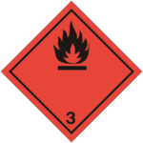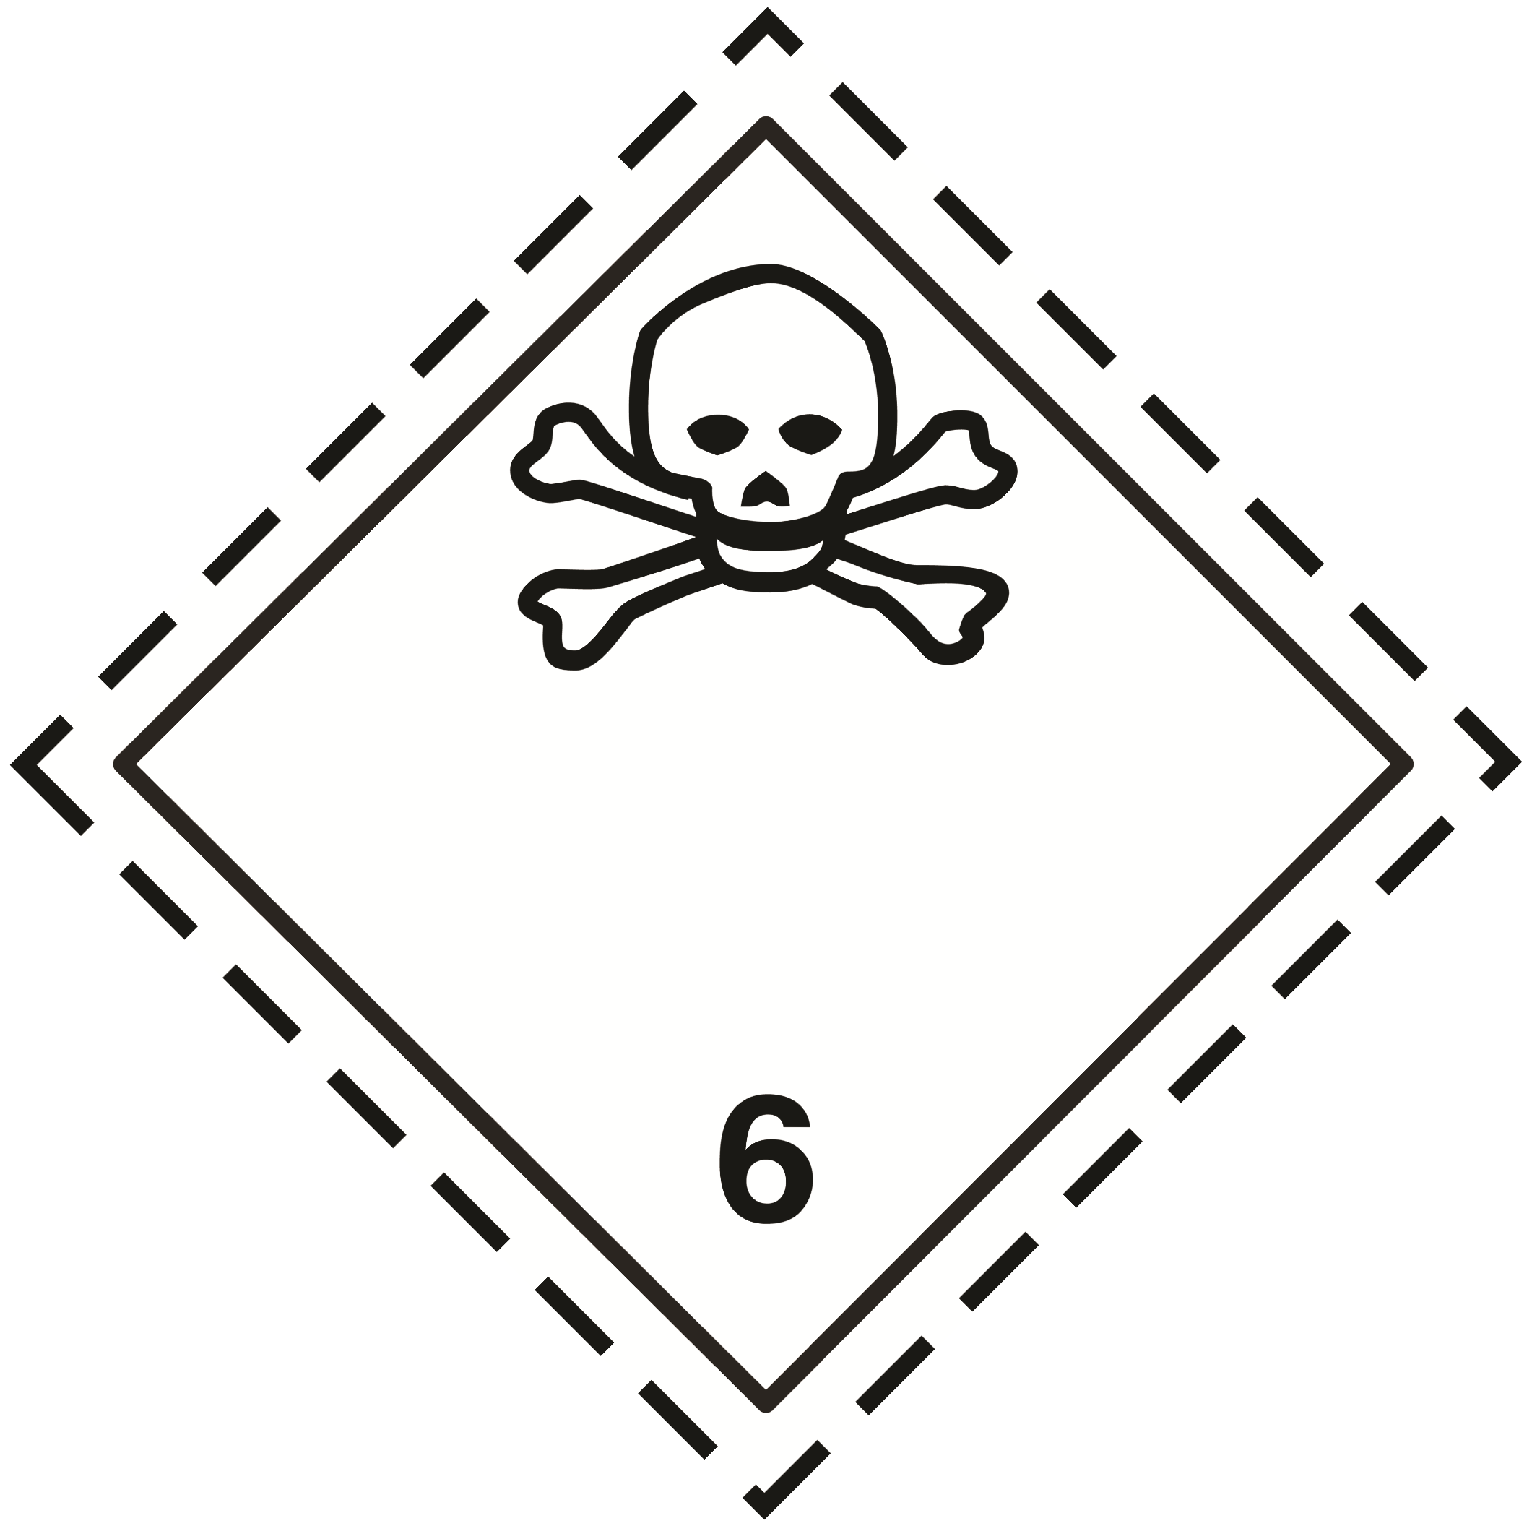
IMDG
Transport hazard class(es) (IMDG) | : | Not applicable
IATA
Transport hazard class(es) (IATA) | : | 3
ADN
Transport hazard class(es) (ADN) | : | Not applicable
RID
Transport hazard class(es) (RID) | : | Not applicable

14.4. Packing group
Packing group (ADR) | : | II
Packing group (IMDG) | : | Not applicable
Packing group (IATA) | : | Not applicable
Packing group (ADN) | : | Not applicable
Packing group (RID) | : | Not applicable

14.5. Environmental hazards
Dangerous for the environment | : | No
Marine pollutant | : | No
Other information | : | No supplementary information available

14.6. Special precautions for user

- Overland transport
Classification code (ADR) | : | FT1
Special provision (ADR) | : | 279
Limited quantities (ADR) | : | 1L
Excepted quantities (ADR) | : | E2
Packing instructions (ADR) | : | P001, IBC02
Mixed packing provisions (ADR) | : | MP19
Portable tank and bulk container instructions (ADR) | : | T7
Portable tank and bulk container special provisions (ADR) | : | TP2
Tank code (ADR) | : | L4BH
Tank special provisions (ADR) | : | TU15
Vehicle for tank carriage | : | FL
Transport category (ADR) | : | 2
Special provisions for carriage - Loading, unloading and handling (ADR) | : | CV13, CV28
Special provisions for carriage - Operation (ADR) | : | S2, S19
Hazard identification number (Kemler No.) | : | 336
Orange plates | : | 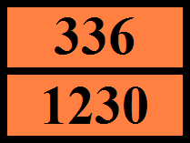
Tunnel restriction code (ADR) | : | D/E
EAC code | : | •2WE
APP code | : | A(fl)
- Transport by sea
MFAG-No | : | 131
- Air transport
No data available
- Inland waterway transport
No data available
- Rail transport
No data available

14.7. Transport in bulk according to Annex II of MARPOL 73/78 and the IBC Code
Not applicable

SECTION 15: Regulatory information

15.1. Safety, health and environmental regulations/legislation specific for the substance or mixture

15.1.1. EU-Regulations

No REACH Annex XVII restrictions
METHANOL 99.8% AR/ACS is not on the REACH Candidate List
METHANOL 99.8% AR/ACS is not on the REACH Annex XIV List

15.1.2. National regulations

Germany
VwVwS Annex reference | : | Water hazard class (WGK) 1, slightly hazardous to water (Classification according to VwVwS, Annex 2; WGK No 145)
12th Ordinance Implementing the Federal Immission Control Act - 12.BImSchV | : | Is not subject of the 12. BlmSchV (Hazardous Incident Ordinance)

Denmark
Class for fire hazard | : | Class I-1
Store unit | : | 1 liter
Classification remarks | : | F <Flam. Liq. 2>; Emergency management guidelines for the storage of flammable liquids must be followed
Recommendations Danish Regulation | : | Young people below the age of 18 years are not allowed to use the product  Pregnant/breastfeeding women working with the product must not be in direct contact with the product

15.2. Chemical safety assessment
No additional information available

SECTION 16: Other information

Full text of H- and EUH-phrases:
Acute Tox. 3 (Dermal) | Acute toxicity (dermal), Category 3
Acute Tox. 3 (Inhalation) | Acute toxicity (inhal.), Category 3
Acute Tox. 3 (Oral) | Acute toxicity (oral), Category 3
Flam. Liq. 2 | Flammable liquids, Category 2
STOT SE 1 | Specific target organ toxicity — single exposure, Category 1
H225 | Highly flammable liquid and vapour
H301 | Toxic if swallowed
H311 | Toxic in contact with skin
H331 | Toxic if inhaled
H370 | Causes damage to organs

This information is based on our current knowledge and is intended to describe the product for the purposes of health, safety and environmental requirements only. It should not therefore be construed as guaranteeing any specific property of the product

