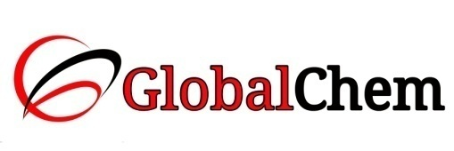

**CERTIFICATE OF ANALYSIS**

PRODUCT NAME : SILICA GEL SELF INDICATING ORANGE 2 - 5 mm

Code no. : SIL2500 CAS no. : 112926-00-8

Lot no. : L185601601 Mfg date : JAN-2016

Exp date : DEC-2020 Analyzed on: 05/01/16

|  |  |  |  |
| --- | --- | --- | --- |
| Sr. no. | Tests | Specifications | Results |
| 1 | Description | Orange coloured crystals | Orange coloured crystals |
| 2 | Loss on drying at 150°C | Max. 2.0% | 1.58% |
| 3 | Water absorption capacity (24 hrs. 80% relative humidity) | Min. 27.0% | 27.0% |
| 4 | Particles size | 2 – 5 mm | Passes test |

This document has been produced electronically and it is valid without signature.